# **Condition:** **Unattached Azure Managed disk.**

**Condition**

**Description:**

* Azure Managed Disks are the new and recommended disk storage offering for use with Azure virtual machines for persistent storage of data.
* Unused disks can accumulate after migration projects, diagnostic drives of VMs, or backups.
* Unused/Orphaned disks are created by deleting VMs in Azure using the Azure Portal or PowerShell.

**Impact:** One of the major reasons for storage costs Partner may not be aware of is the presence of unused virtual hard disks (VHDs) in his storage account & that will impact Azure storage cost.

**Criticality:** Non-Critical Impact

**Frequency:** 24hrs

**Trigger Details**

**Trigger Condition:** Alert will be triggered if diskState is **“unattached”**.

**Method to capture trigger point:**

* REST API can be used to capture the alert trigger point.
* REST API URI is as mentioned below:

[https://management.azure.com/subscriptions/{subscriptionId}/providers/Microsoft.Compute/disks?api-version=2019-03-01](https://management.azure.com/subscriptions/%7bsubscriptionId%7d/providers/Microsoft.Compute/disks?api-version=2019-03-01)

* Reference link:

<https://docs.microsoft.com/en-us/rest/api/compute/disks/list>

* Alert will be triggered if “diskState" is "Unattached”.

**Sample Output from API:**

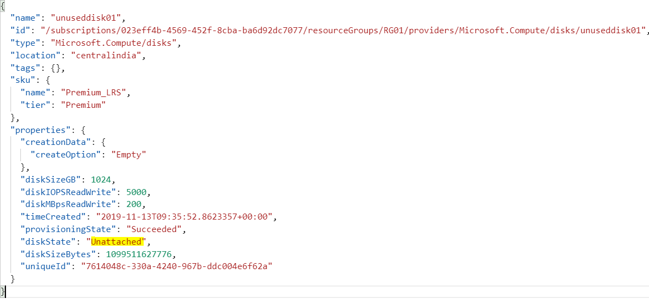

**Alert Details**

**Alert Category:** Azure Storage

**Details required along with Alert:**

1. Subscription ID.
2. Resource Group Name.
3. Disk Name.
4. Disk Size in GB.